**TUNKU ABDUL RAHMAN UNIVERSITY COLLEGE**

FACULTY OF COMPUTING AND INFORMATION TECHNOLOGY

BAIT2133 WEB ENGINEERING

WONG KAI YIN & TAN PAK KIN

ASSIGNMENT

SEPTEMBER 2020

100 Marks(50%)

**Introduction.** Library management systems provide Mufti-Function which is used by librarian and administrator to better manage library and user. Library management systems help librarians reduce the workload on managing books and provide services that let users efficiently perform tasks.

**1.Problem Statement and Solution**

In the existing library system, many tasks need to be manually managed by librarians, which will increase the workload faced by librarians. With the passage of time and the increase of library users and book data, existing libraries cannot effectively handle the requirements of users and librarians.

|  |  |
| --- | --- |
| Problem faced by existing system | Solutions that can be provided by the web application. |
| Problems of recovery and Preservation. The library paper transactions documents and reports are easy to damage by water, fire and other perils. Manual library management systems at risk of losing these data, sometimes cannot recover these damaged data. Some librarians revealed that sometimes they will lose documents when rearranging these documents. | Highly Secure Database and data recovery. The library management system provides data security in which all data is stored in the database digitally and can make an exact copy of the original data many times. |
| Time consuming to search. The manual library system is time consuming in searching books if not familiar with the library. This is because the manual library system only can search by classification and cannot search by keyword. | Powerful Search Engine.The library management system can reduce time consuming to search books even though not familiar with the library and also provides a more efficient search engine that can search books by keyword anywhere in the library. |
| Prone to human error. The operation paper work of manual library management systems is all done by humans, this will increase the number of error operations such as incorrect recording of a document and misplaced book. | Efficient operation management. The library management system can remove all operation paperwork. Managing libraries by automated means minimal human error because it can track all changes made by librarians so that librarians can keep track of their operations and alter them.. |
| Lack of Information. The status of the book and process of a transaction report of the library are slow when everything is done as paperwork. Many students are being time wasted because the book is borrowed by other students. | Dynamic Reports. The library management system provides faster retrieval of information about books and reports. After having this web application, students can check on  applications to prevent time consuming. |
| Higher costs. The manual library management system needs to spend a lot of money on paper, printers, manpower and other stationery to do all the operations. These expenses will add up over time. | Cost-effective. The cost of library management systems are lower than manual library management systems, because library management systems can remove all paperwork to reduce operation costs and also can reduce the need of manpower to maintain the system because it can be automated. |

**2.Development Plan & Project Team Chart**

|  |  |
| --- | --- |
| **Requirements Analysis** | **Description** |
| User Role | System able to verify user roles such as user, librarian, and administrator. Each role has a different function, for the user function is able to borrow, return, renew books and be able to pay fines. For Librarians able to add, edit, delete books, and be able to create fines for users. For an Administrator able to create a librarian account, recover damaged data, and data analysis. |
| Books | Every book recorded in the database should have it’s BookId, BookName, BookAuthor, BookCategory, BookStatus which are able to help users to search. |
| System | System able to verify and authentication every user role login and also for administrator should have security logout if no operation in 10 minutes. Besides that, systems are able to send notifications such as return due date notification and logoff notification for administrators. |

Design Methods.

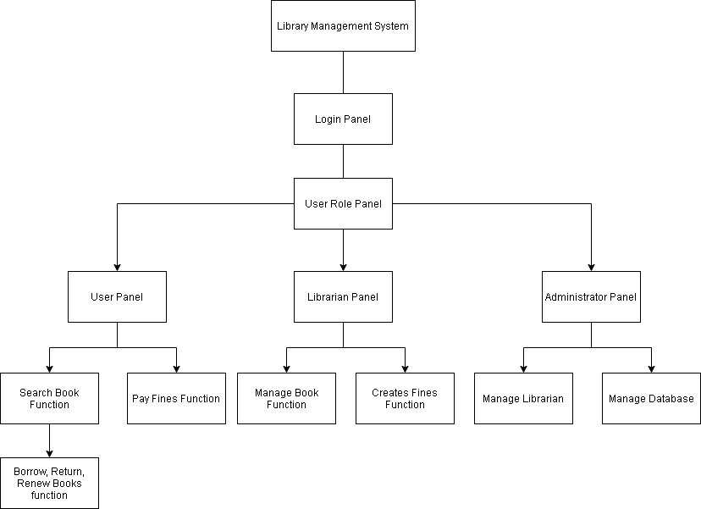

Testing methods. Software testing plays an important role in the software life cycle. software testing is in the operation and maintenance phase, and it is an important means to ensure the quality of the software before the software products are delivered to the user.

|  |  |
| --- | --- |
| Testing Method Quality Dimensions | Description |
| Content | We are testing to ensure the content such as requirement description, project plan description and project role description are clear, understandable. |
| Function | We are testing the function to ensure our project functions meet stakeholders requirements. Besides that, we test for each stage of project system correctness to appropriate requirements standards. |
| Usability | We are testing the usability of systems that are easy to use for every user. We test for some functions such as borrow book operation by apply some navigation remind to ensure user can understandable to use the function. |

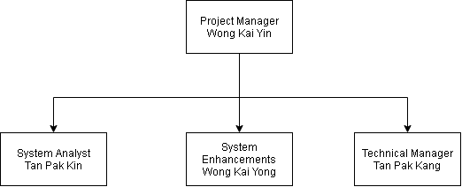

|  |  |
| --- | --- |
| **Project Role** | **Responsibilities** |
| Project Manager | The Project Manager is responsible for managing the project. Besides that, the project manager plans the project scope, title and schedule of the project. Lastly, the project manager is also responsible for communicating with stakeholder and project team to ensure the quality of the system. |
| System Analyst | System Analyst is responsible for gathering all system requirements. System analyst also responsible for communicating with stakeholders to plan the project flow. Lastly, system analyst responsible for providing UML diagrams to help development projects. |
| System Enhancements | System Enhancements is responsible for increasing the quality of the system such as, correcting UML diagrams to meet stakeholder requirements, adding new features to increase the quality of the system, and analyzing enhancement requirements.. |
| Technical Manager | The Technical Manager is responsible for deciding the project strategy. Besides that, the technical manager is also responsible for providing technical support to the project team to troubleshoot technical issues. Lastly, the technical manager is responsible for analysis project error to ensure project correctness. |

|  |  |  |  |  |  |  |  |
| --- | --- | --- | --- | --- | --- | --- | --- |
| **Project Plan** | Week 1 | Week 2 | Week 3 | Week 4 | Week 5 | Week 6 | Week 7 |
| Decide Web Application |  |  |  |  |  |  |  |
| Gather Requirement Analysis |  |  |  |  |  |  |  |
| Plan Scope System |  |  |  |  |  |  |  |
| Model Web Application |  |  |  |  |  |  |  |
| Project Complete |  |  |  |  |  |  |  |
| Correction To Project |  |  |  |  |  |  |  |
| Final Project Complete |  |  |  |  |  |  |  |

**3.Requirement Elicitation & Formulation**

Describe what activities can be organized to elicit requirements. You are required to provide a list of functional requirements & non-functional requirements, and group the requirements into categories.

**Elicit Requirements.**

Interviews. We had structured interviews with stakeholders to gather requirement information. We also had group interviews to see the goals and critical issues, subjective of the system. Interviews are good to get an overall understanding of what stakeholders need, their concept ideas on a new system, and the difficulties they face with the current system.

Brainstorming. We use brainstorming techniques to help us to make a summary of all information and ideas to organize our ideas on a system.We gather stakeholders and the exchange of ideas in an open way to think about different answers and questions we haven't thought about before.

Structure analysis. We analyze the structure of the system to ensure the system’s logical structure meets with stakeholder requirements. It also allows us to find logic errors of the navigation structure of the system to complete an accuracy system that stakeholders are satisfied with.

**Functional Requirement:**

1. Add Books

-System must be able to save new books in the database.

-System must be able to not allow two books having the same book id.

2. Edit Books

-System must be able to save new changes in the database.

-System must be able to verify duplicate unique data and send error messages.

3. Delete Books

-System must be able to delete any book in the database.

-System must be able to send warning messages to users when they delete a book.

4. Register New Account

-Every user must be able to register a new account.

-Every account must have an unique ID.

5. Login/Logout

-User, Librarian, and Administrator must have login authentication to access the system.

-System must allow only User, Librarian, and Administrator with valid id and password to access the system.

-System must be able to verify to decide which user role level can access to.

-User, Librarian, and Administrator must log out after using the system.

6. Search Book

-All user role levels can search any books.

-System must be able to filter books based on keyword entered.

7. Update Account

-All users' role levels must be able to update their account information.

-Any changes must be made to save in the database.

8. Borrow Book

-System must allow users to borrow any book when the book is available to borrow.

-System must be able to verify the book's status before the user borrows the book.

-System must be able to generate the due date of the book to the user.

9. Renew Book

-System must allow users to renew books if the book is available and users are paid fines.

-System must be able to generate a new due date of the book to the user.

10. Return Book

-System must allow the user to return any book.

-System must be able to send notifications to users to remind them about the due date of books.

-System must be able to change the status of the book after the user returns the book.

-System must be able to send notification of pay fine to the user if no return within due date.

**NonFunctional Requirement:**

1.Safety Requirements

-The database must be able to recover data in case data gets damaged at any certain time due to virus or operating system failure.

2.Performance Requirements

-The system must be very fast and accurate when the user, librarian and administrator use the system.

- The system must be able to process a large amount of data and ensure the system is running as smooth.

3.Usability Requirements

-The system design must be easy to use for all users so that they can perform various tasks effectively.

4.Security Requirements

-Different user levels have different access rights.

-Only an administrator can access the database to perform various tasks.

-Only an administrator can view and manage user accounts.

-Security authentication will be used in user login.

1. **Requirements Modeling**

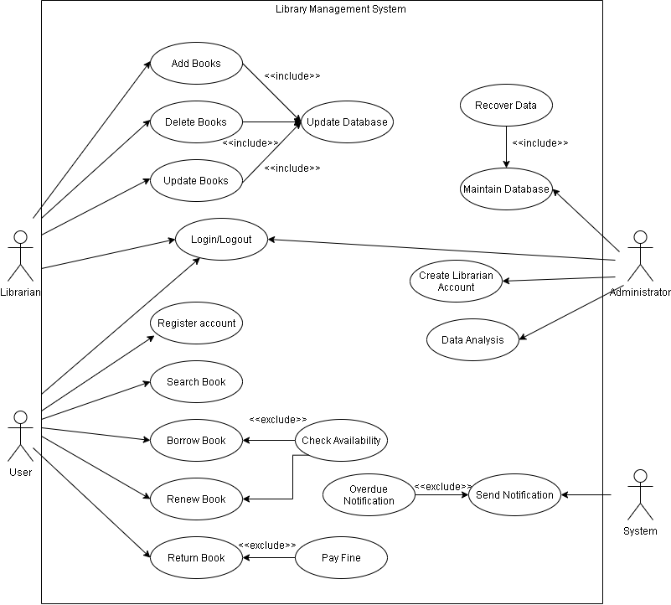

**Use Case Description**

|  |  |  |
| --- | --- | --- |
| Use Case Name: Add Books | | |
| Use Case Description: Librarian want to add books | | |
| Actors: Librarian | | |
| Pre-Condition: The Actor have Librarian account | | |
| Post-Condition: After add books will update record to database | | |
| Main Scenarios | Serial No | Steps |
| Actors/Librarian | 1 | Login into system as librarian |
|  | 2 | Select add book button on menu |
|  | 3 | Enter the name, Author’s name, book category of book details |
|  | 4 | The books record will update to the database after the librarian clicks the confirmation of add books notification. |
| Extensions | 1a | Invalid Password  System show error message |
|  | 4b | Librarian click “no” to refuse update  System back to serial 3 |

|  |  |  |
| --- | --- | --- |
| Use Case Name: Delete Books | | |
| Use Case Description: Librarian want to delete books | | |
| Actors: Librarian | | |
| Pre-Condition: The Actor have Librarian account | | |
| Post-Condition: After delete books will update record to database | | |
| Main Scenarios | Serial No | Steps |
| Actors/Librarian | 1 | Login into system as librarian |
|  | 2 | Select delete book button on menu |
|  | 3 | Enter the book’s id |
|  | 4 | The books record will update to the database after the librarian clicks the confirmation of delete books notification. |
| Extensions | 1a | Invalid Password  System show error message |
|  | 3b | Book’s id not found  System show error message require librarian enter again |
|  | 4c | Librarian click “no” to refuse update  System back to serial 3 |

|  |  |  |
| --- | --- | --- |
| Use Case Name: Update Books | | |
| Use Case Description: Librarian want to update book’s information | | |
| Actors: Librarian | | |
| Pre-Condition: The Actor have Librarian account | | |
| Post-Condition: After update book’s information will update record to database | | |
| Main Scenarios | Serial No | Steps |
| Actors/Librarian | 1 | Login into system as librarian |
|  | 2 | Select update book button on menu |
|  | 3 | Enter the book’s id |
|  | 4 | Enter the information of book |
|  | 5 | The books record will update to the database after the librarian clicks the confirmation of update books notification. |
| Extensions | 1a | Invalid Password  System s*h*ow error message |
|  | 3b | Book’s id not found  System show error message require librarian enter again |
|  | 4c | Librarian click “no” to refuse update  System back to serial 3 |

|  |  |  |
| --- | --- | --- |
| Use Case Name: Register account | | |
| Use Case Description: User want to register account | | |
| Actors: User | | |
| Pre-Condition: The Actor must have all necessary information to register | | |
| Post-Condition: After registering an account the details of the account will display on the personal page. | | |
| Main Scenarios | Serial No | Steps |
| Actors/ User | 1 | Select register account on menu |
|  | 2 | Fill in all the details of the account required. |
|  | 3 | Confirmation of register account. |
|  | 4 | The account have been created, user can login to their account |
| Extensions | 2a | Invalid details  System s*h*ow error message |
|  | 3b | User click “no” to refuse register account  System back to serial 2 |
|  |  |  |

|  |  |  |
| --- | --- | --- |
| Use Case Name: Login to library management system | | |
| Use Case Description:User, Librarian,and Administrator want to login to library management system | | |
| Actors: User, Librarian, Administrator | | |
| Pre-Condition: The Actor must have internet to use the system | | |
| Post-Condition: A notification will be sent to the Actor after login to system. | | |
| Main Scenarios | Serial No | Steps |
| Actors/ User/Librarian/Administrator | 1 | Select login on menu |
|  | 2 | Enter username and password |
|  | 3 | Validate Username, password, and user level |
|  | 4 | Access to library management system |
| Extensions | 2a | Invalid username and password  System show error message and Actor can choose forgot password to find its password |
|  | 3b | Invalid password more than 5 times  Actor not allow to login 5 minutes |

|  |  |  |
| --- | --- | --- |
| Use Case Name: Search Book | | |
| Use Case Description: User want to search book | | |
| Actors: User | | |
| Pre-Condition: The Actor must open library management system | | |
| Post-Condition: A search record will save in search history | | |
| Main Scenarios | Serial No | Steps |
| Actors/ User | 1 | Select search button on menu |
|  | 2 | Actor enter the keyword of book |
|  | 3 | Actor received the result |
|  | 4 | Actor close the system. |
| Extensions | 2a | The system fails to search  System will send notification to inform actor |
|  | 3b | Actor not satisfied with the result  System will back to serial 2 |

|  |  |  |
| --- | --- | --- |
| Use Case Name: Borrow Book | | |
| Use Case Description: User want to borrow book | | |
| Actors: User | | |
| Pre-Condition: The Actor must login to user account | | |
| Post-Condition: A notification will send to user after borrow books | | |
| Main Scenarios | Serial No | Steps |
| Actors/ User | 1 | Select borrow book button on menu |
|  | 2 | Actor enter the keyword of book |
|  | 3 | Check availability of the book |
|  | 4 | Actor receive the book |
| Extensions | 1a | The number of books that the user can borrow is full  System send notification to user |
|  | 2b | The system fails to search  System will send notification to inform actor |
|  | 3c | Book are not available  System will send notification to user and back to serail 2 |
|  | 4d | Status of book will update to not available  System will send a deadline to user for returning book |

|  |  |  |
| --- | --- | --- |
| Use Case Name: Renew Book | | |
| Use Case Description: User want to renew book | | |
| Actors: User | | |
| Pre-Condition: The Actor must login to user account | | |
| Post-Condition: A notification will send to user after renew books | | |
| Main Scenarios | Serial No | Steps |
| Actors/ User | 1 | Select renew book button on menu |
|  | 2 | Actor select a book in the list |
|  | 3 | Check availability of the book |
|  | 4 | Deadline of the returning date will extend |
| Extensions | 2a | The number of user can renew are full  System send notification to user |
|  | 3b | Book are not available  System will send notification to user and back to serail 2 |
|  | 4c | System will send a new deadline to user for returning book  Number of user can renew will deduct to zero |

|  |  |  |
| --- | --- | --- |
| Use Case Name: Return Book | | |
| Use Case Description: User want to return book | | |
| Actors: User | | |
| Pre-Condition: The Actor must login to user account | | |
| Post-Condition: A notification will send to user after return books | | |
| Main Scenarios | Serial No | Steps |
| Actors/ User | 1 | Select return book button on menu |
|  | 2 | Actor select a book in the return list |
|  | 3 | Check return date of the book |
|  | 4 | The status of the book will update to available |
| Extensions | 3a | The book is not returned on time  System send a fine slip to user |
|  | 3b | User account cannot use the function of library management system after user pay fine  System will send a notification to user |

|  |  |  |
| --- | --- | --- |
| Use Case Name: Maintain Database | | |
| Use Case Description: Administrator want to maintain database | | |
| Actors: Administrator | | |
| Pre-Condition: The Actor open the library management system | | |
| Post-Condition: The Actor close application after using the system | | |
| Main Scenarios | Serial No | Steps |
| Actors/ Administrator | 1 | The Actor login to the system as Administrator role. |
|  | 2 | Actors select recovery data on the menu. |
|  | 3 | The actor saves the changes. |
|  | 4 | The actor logs out after using the system. |
| Extensions | 3a | The book is not returned on time  System send a fine slip to user |
|  | 1a | Invalid username and password  System send authentication to actor |
|  | 3b | Changes will update to database  System will send a notification to actor to remind user |
|  | 4c | No changes is make in 10 minutes, user will forced logs out  System will send a notification to user to remind user have been logs out |

|  |  |  |
| --- | --- | --- |
| Use Case Name: Create Librarian Account | | |
| Use Case Description: Administrator want to create Librarian Account | | |
| Actors: Administrator | | |
| Pre-Condition: The Actor open the library management system | | |
| Post-Condition: The Actor close application after using the system | | |
| Main Scenarios | Serial No | Steps |
| Actors/ Administrator | 1 | The Actor login to the system as Administrator role |
|  | 2 | Actor select create librarian Account |
|  | 3 | The Actor enter all the detail of librarian |
|  | 4 | Confirmation of register account. |
|  | 5 | The account have been created, Librarian can login to their account |
|  | 6 | The Actor logs out after using the system |
| Extensions | 1a | Invalid username and password  System send authentication to actor |
|  | 3b | Invalid details  System s*h*ow error message |
|  | 4c | User click “no” to refuse register account  System back to serial 2 |
|  | 6d | No changes is make in 30 minutes, user will forced logs out  System will send a notification to user to remind user have been logs out |

|  |  |  |
| --- | --- | --- |
| Use Case Name: Data Analysis | | |
| Use Case Description: Administrator want to analysis data | | |
| Actors: Administrator | | |
| Pre-Condition: The Actor open the library management system | | |
| Post-Condition: The Actor close application after using the system | | |
| Main Scenarios | Serial No | Steps |
| Actors/ Administrator | 1 | The Actor login to the system as Administrator role. |
|  | 2 | Actors select analysis data on the menu. |
|  | 3 | The Actor customize data that want to analyze. |
|  | 4 | Actor received the result. |
|  | 5 | The Actor logs out after using the system. |
| Extensions | 1a | Invalid username and password.  System sends authentication to the actor. |
|  | 4b | Actorare not satisfied with the result.  System back to serial 3. |
|  | 6d | No changes are made in 30 minutes, the actor will force logs out.  System will send a notification to the actor to remind actors they have been logged out. |

**5.Content Model**

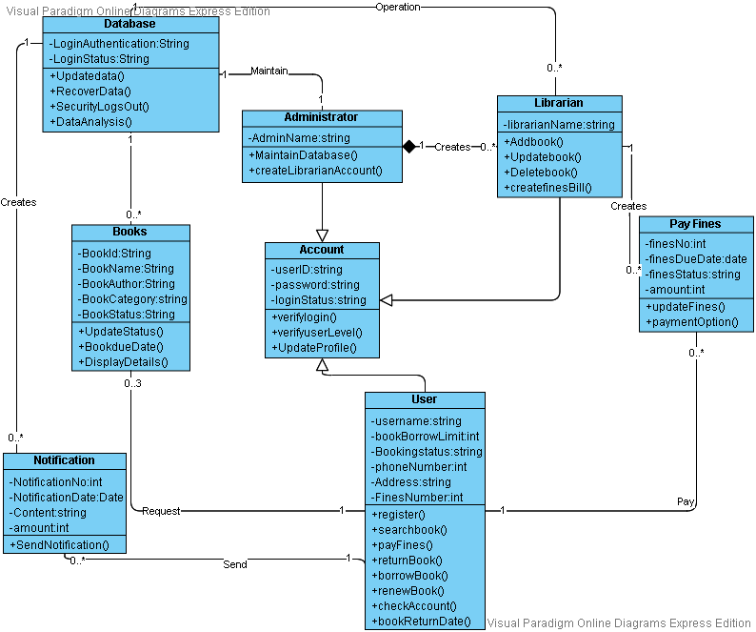

**6.Hypertext Model**

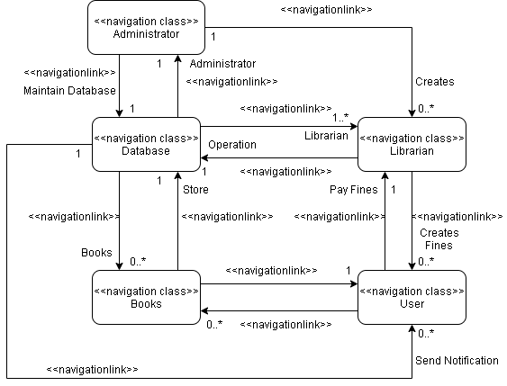

**7.Presentation Model**

image image presentationPage presentationPage text text button button

inputForm inputForm presentationAlternativespresentationAlternatives textInput textInput

**Library management system home page**

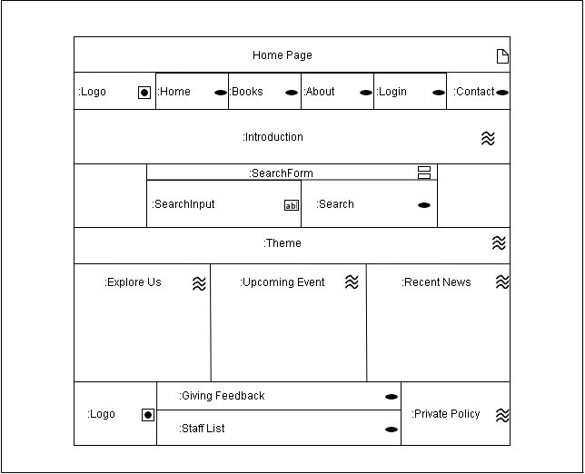

**Library management system login page**

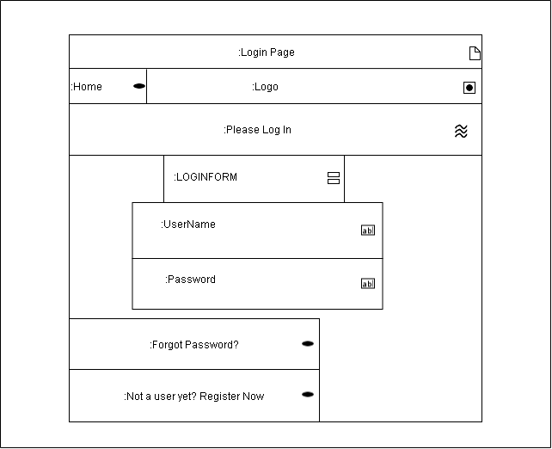

**Library management system register page**

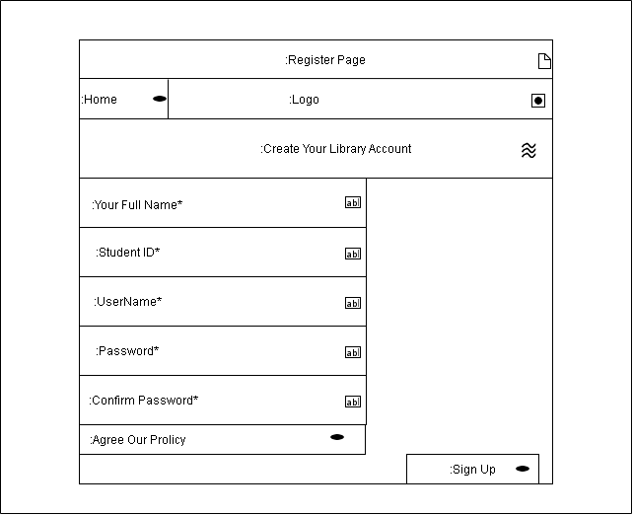

**Library management system Administrator home page**

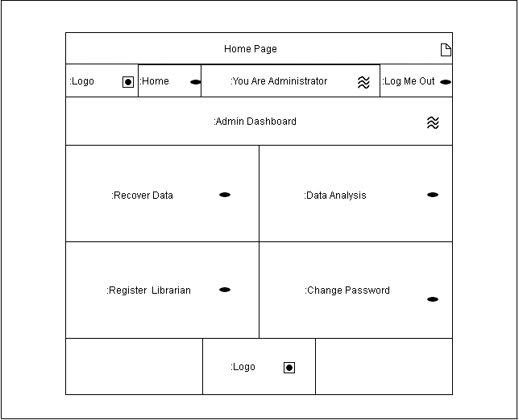

**Library management system Administrator Recover Data Page**

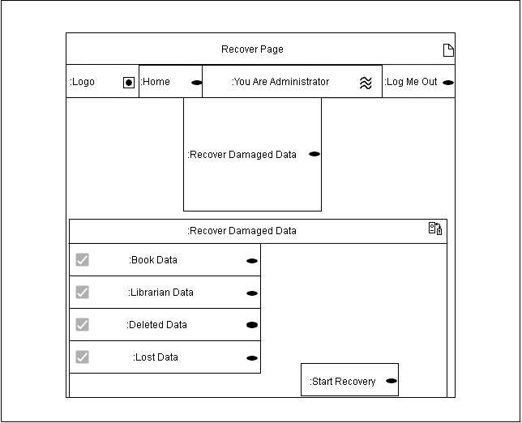

**Library management system Administrator Analysis Data page**

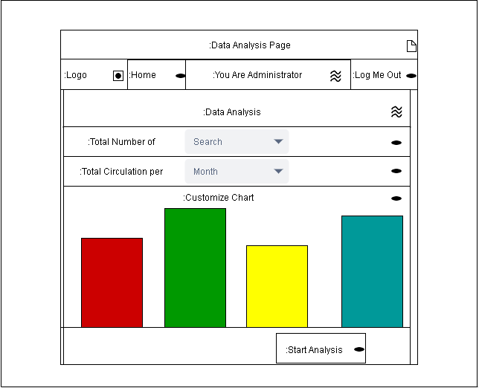

**Library management system Administrator register librarian account page**

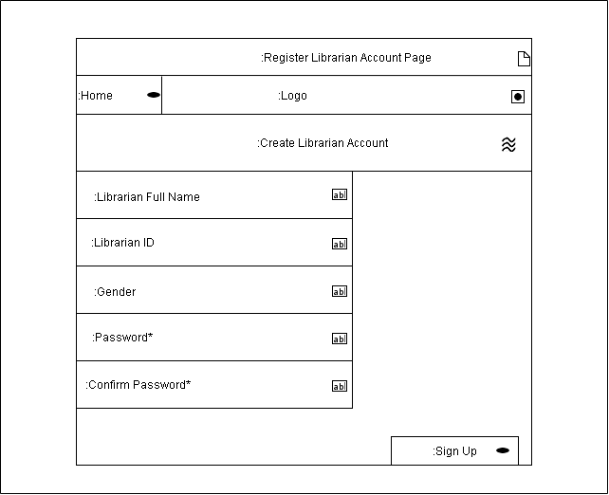

**Library management system home page for librarian**

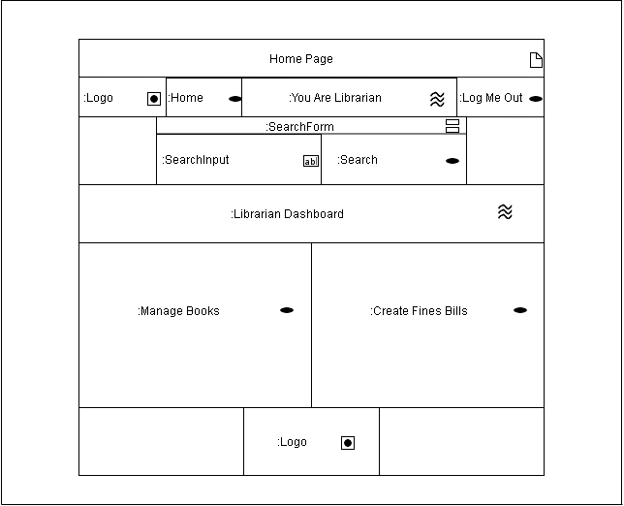

**Library management system Librarian manage book page**

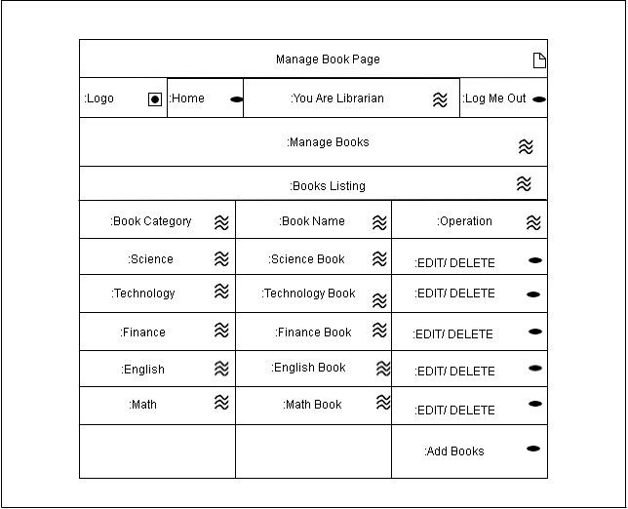

**Library management system add books page**

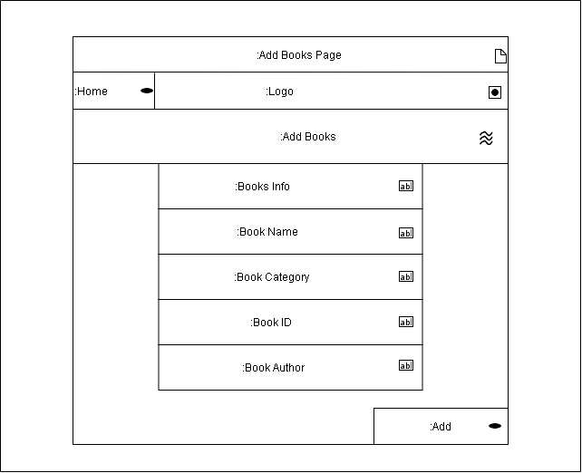

**Library management system edit book page**

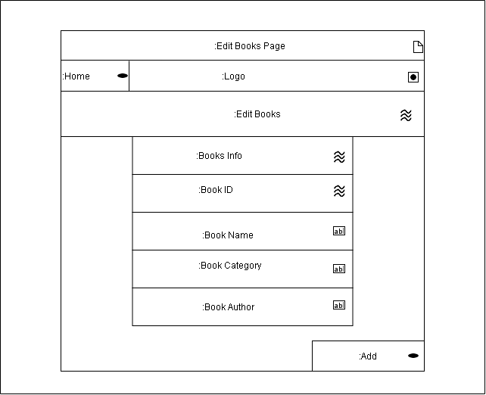

**Library management system delete books page**

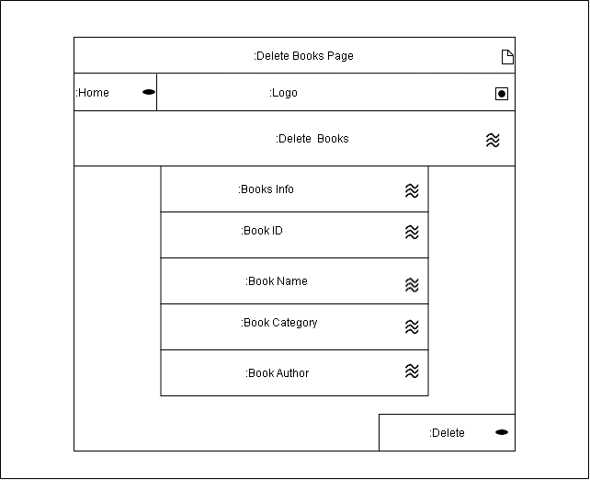

**Library management system create fines bills**

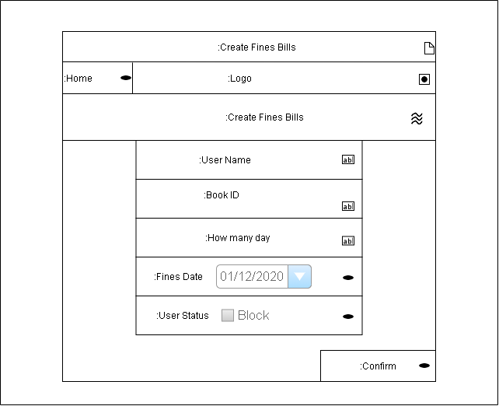

**Library management system home page to user**

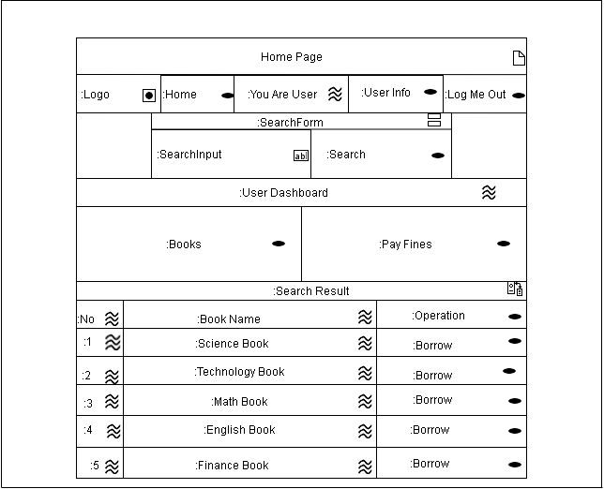

**Library management system book page**

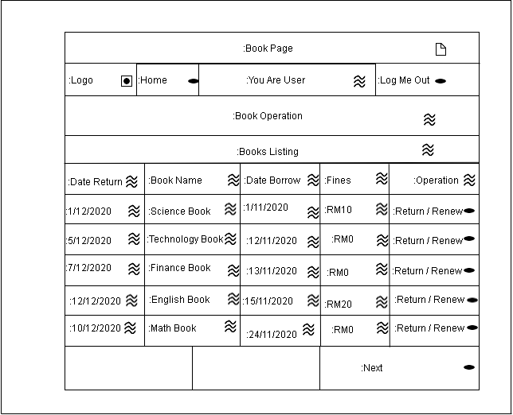

**Library management system User info page**

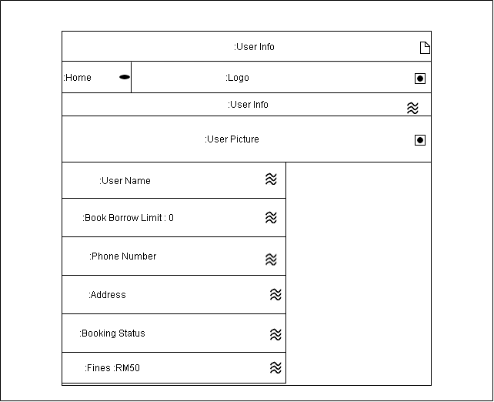

**Library management system pay fines page**

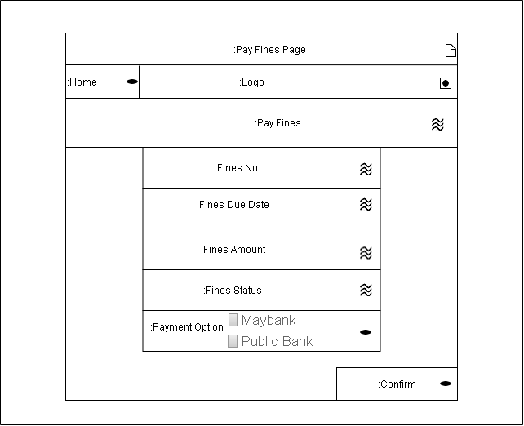

**Library management system borrow page**

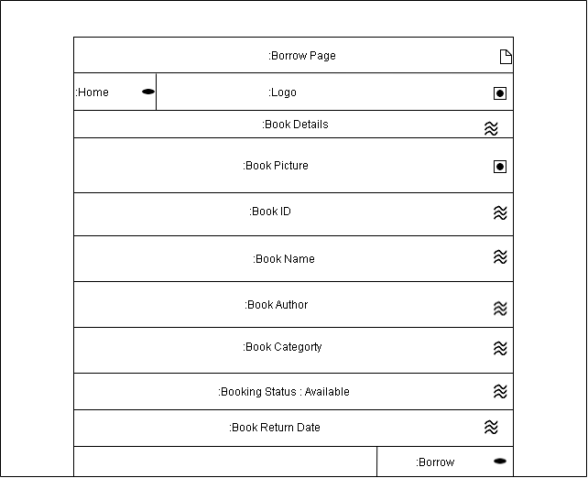

**8.Functional Model**

**User Panel flow and logical decisions**

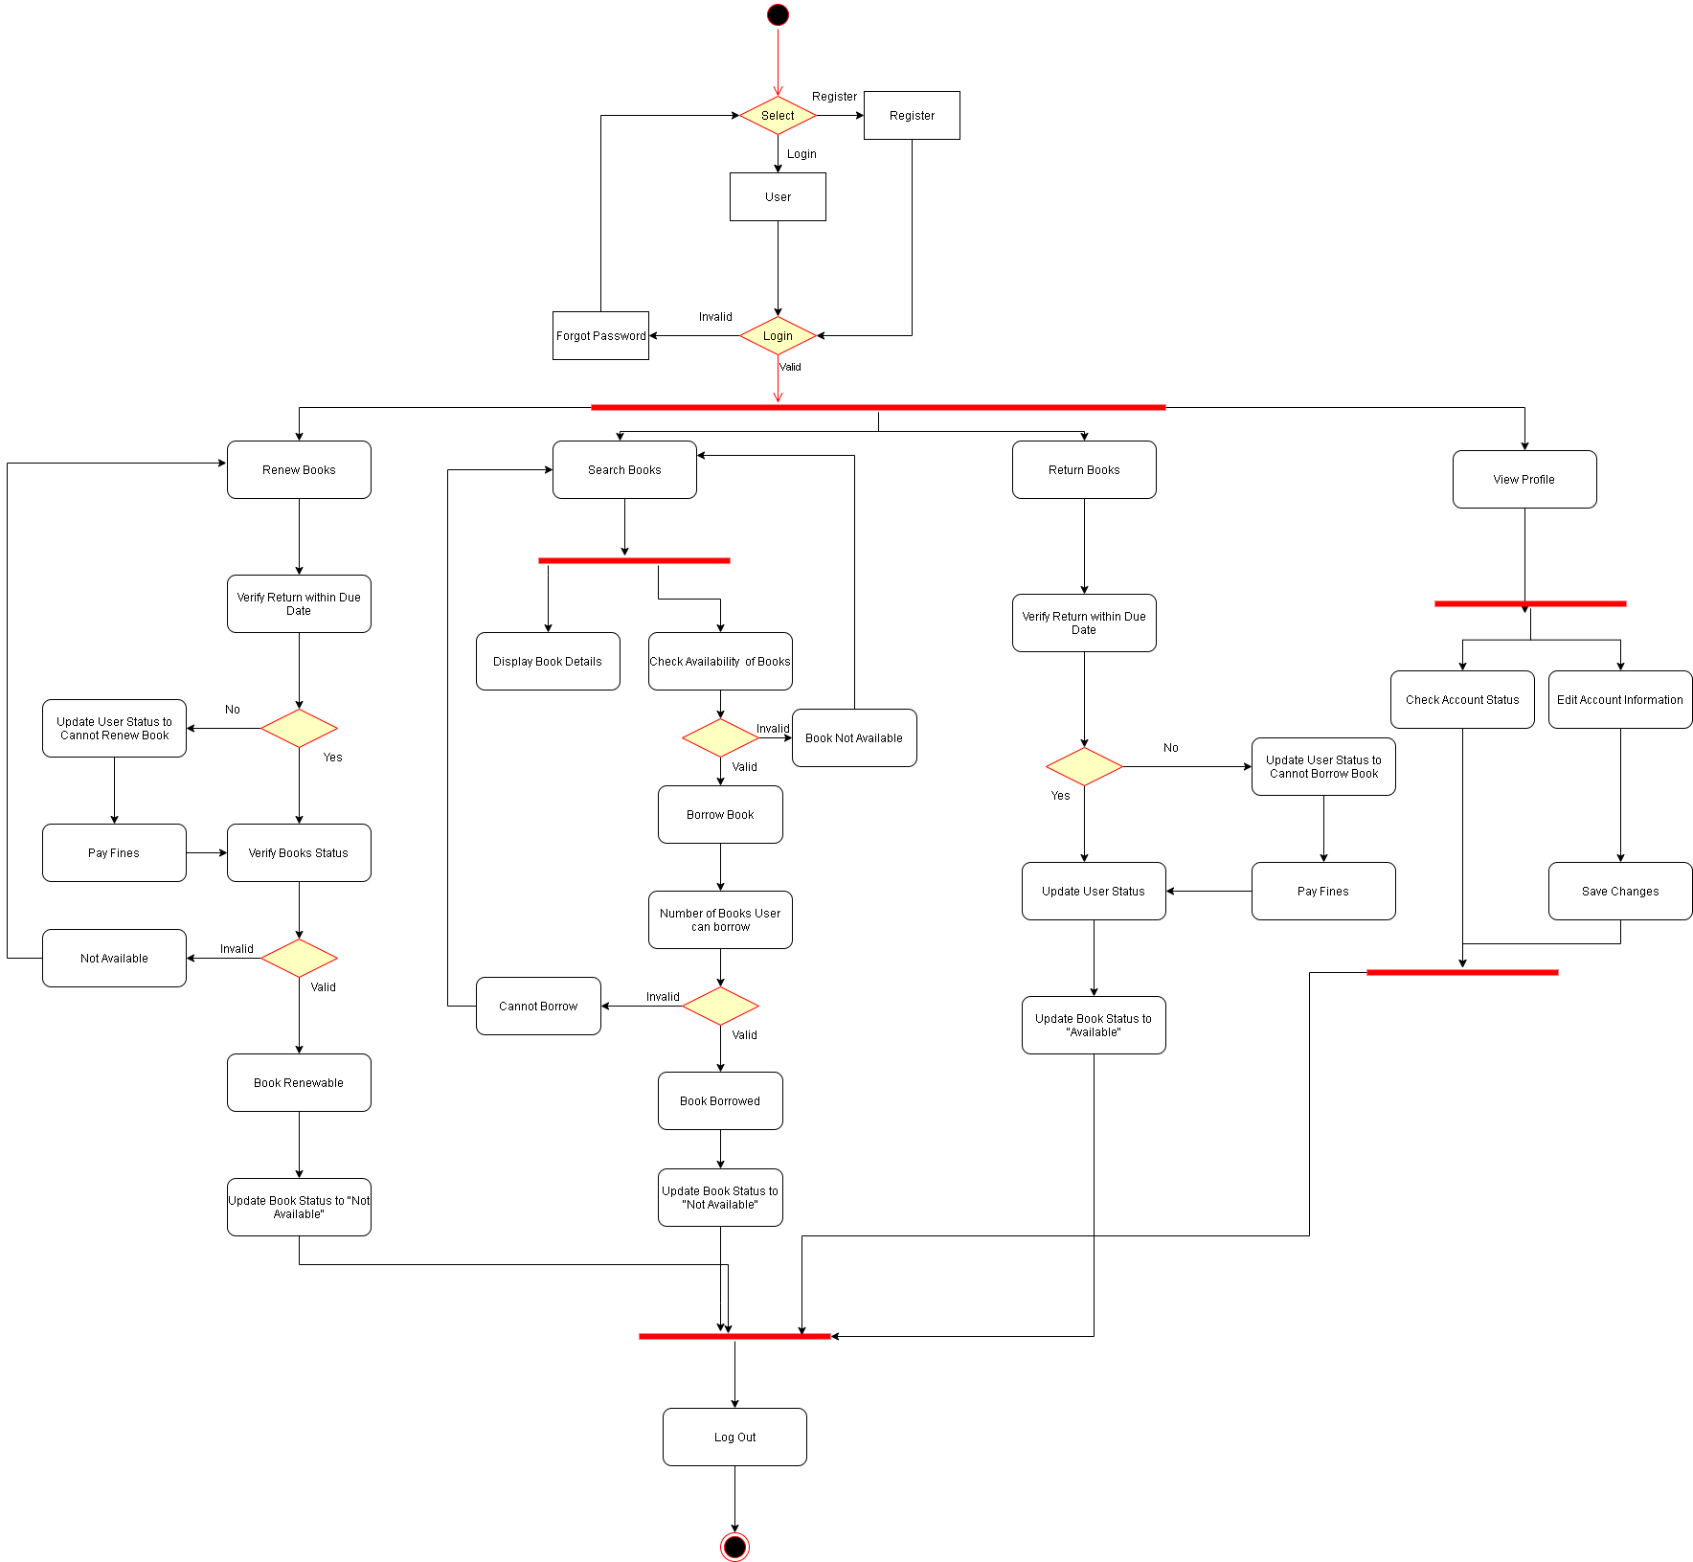

**Librarian Panel flow and logical decisions**

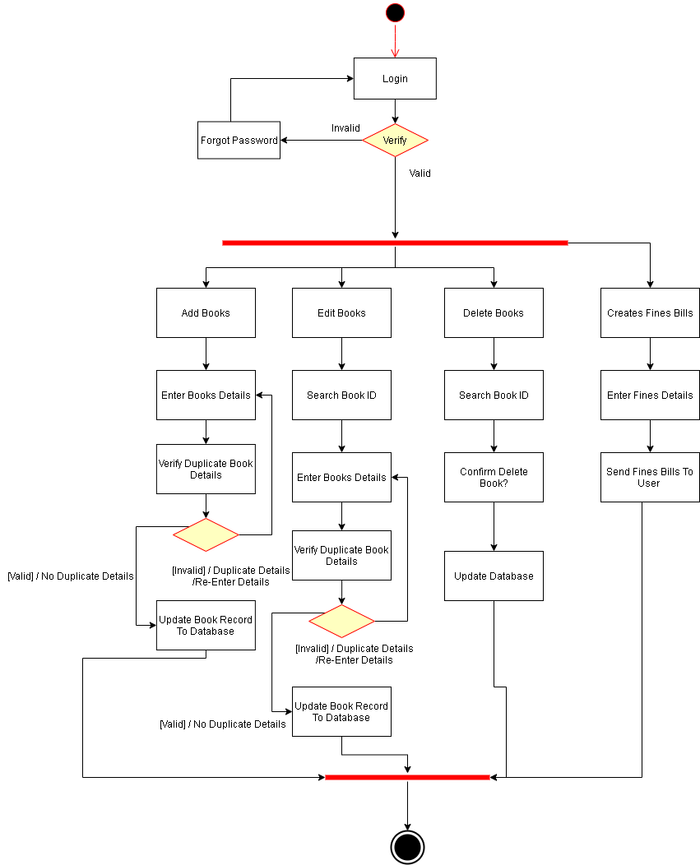

**Administrator Panel flow and logical decisions**

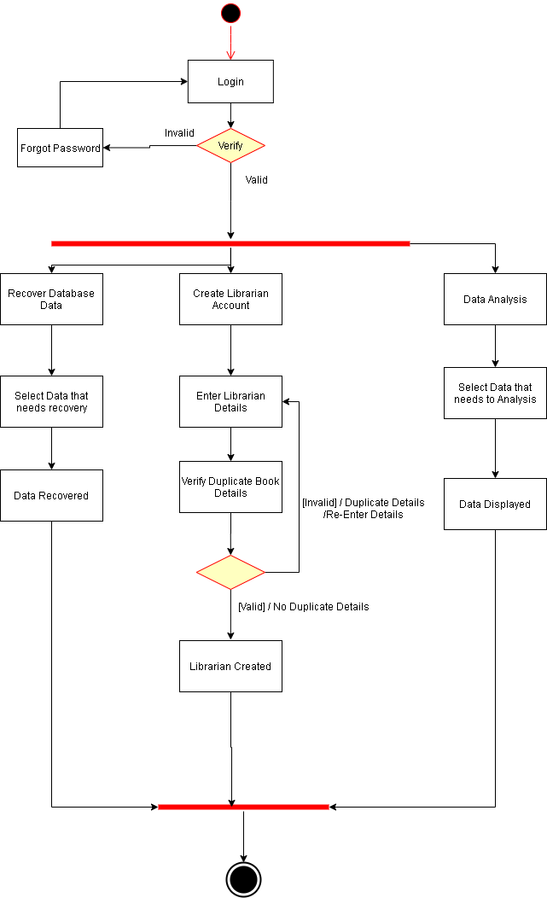

**9.Interaction Model**

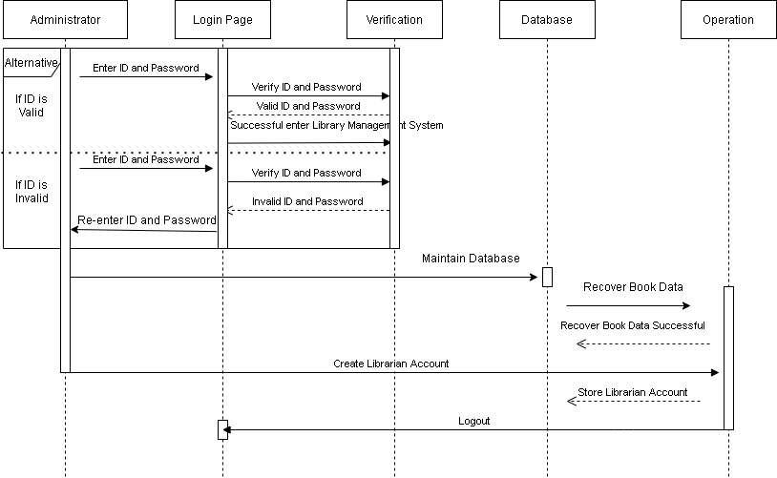

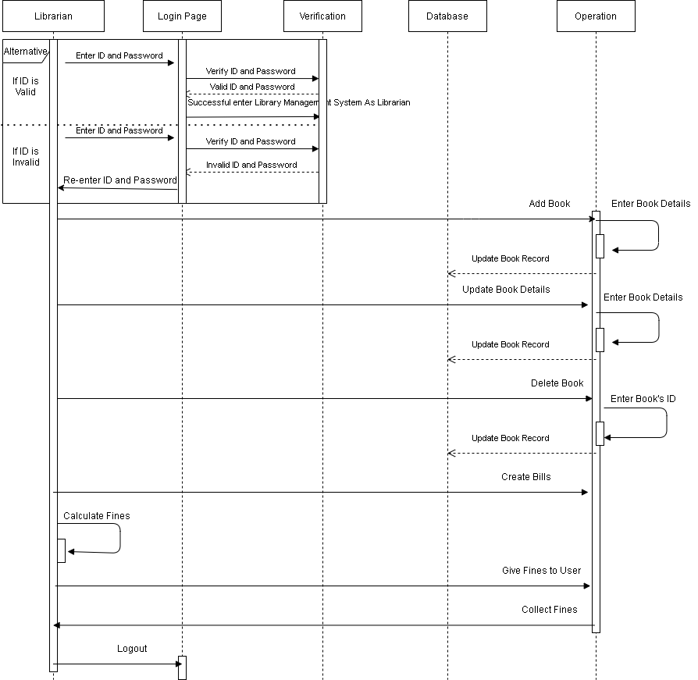

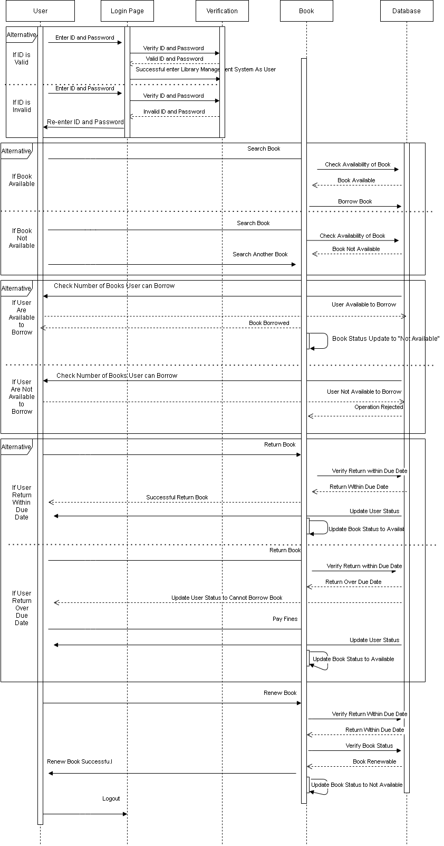**10.Configuration Model**

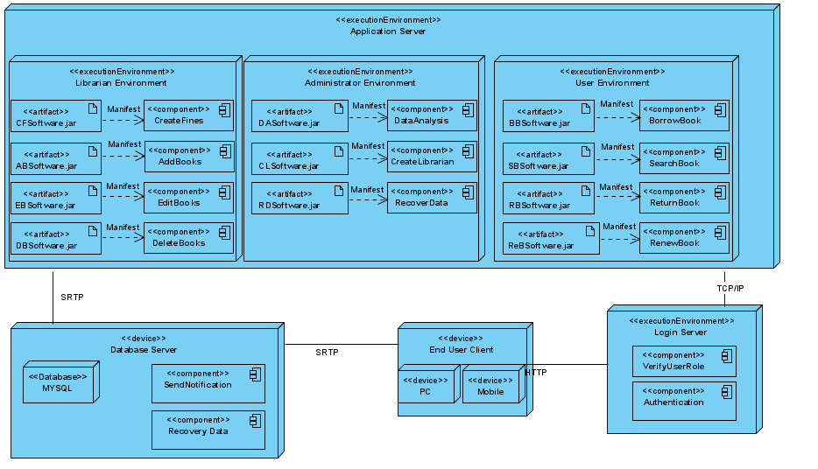

|  |  |
| --- | --- |
| Strength | Limitations |
| Library management systems ensure only staff can view the personal information of library users. Verification and authentication will protect the data of the system and the privacy of user information. The library system is more secure and reliable. | The library management system does not have a communication function to let users share their reading experience to each other on the platform. |
| Library managers can easily perform data analysis to make decisions. For example, use data analysis to find out which type of book is more popular, and increase this type of book to attract people to use the library. | The library management system does not have a reservation book function, this cause borrowing a book must check availability of the book. |
| All data in the library management system will be automatically uploaded to the cloud platform. In the event of an accident, it will ensure that data can be recovered at any time | The library management system database only the administrator can manage with, this may cause some damaged data cannot recover at time if administrators have other things busy with. |

**Summary**

The library management system is a computer system used to maintain all the daily work of the library in order to reduce costs and workload. In order to improve and reduce shortcomings, we already collect different opinions from all stakeholders and understand their needs before design. To ensure that the design details and content are sufficient and executable, we prepare various diagrams to view from many different aspects.We have also prepared different models to review this library management system working principles to ensure that there are no defects. We guarantee that the system is modern and reliable because it can protect all the data from any state. At the same time, the user's personal information is also protected, and the librarian can easily find the user's status for management. The library management system can easily help the library improve library services and make users prefer to use the library. However, there are still some shortcomings in the library management system. I believe that as long as the technology is mature, it can be solved or improved.